AI-Based Student Wellbeing Monitoring System for Sri Lankan Schools
R26-IT-165

Project Proposal Report
Zoysa A.K.T.D. – IT19064482

B.Sc. (Hons) Degree in Information Technology Specialized in Information Technology

Department of Information Technology

Sri Lanka Institute of Information Technology Sri Lanka

March 2026

DECLARATION

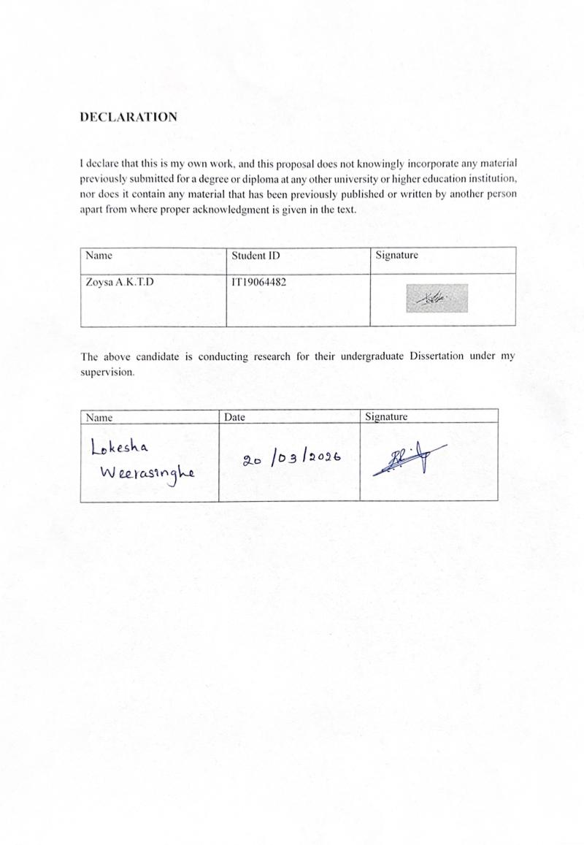

ABSTRACT

This proposal outlines the development of an Integrated Monitoring, Visualization, and AI-Driven Learning Support Dashboard tailored to address the unique challenges of the Sri Lankan education system. Currently, Sri Lanka faces a critical student retention issue, with approximately 20,000 students dropping out annually and another 80,000-attending school irregularly. This platform aims to bridge the gap between existing data systems like NEMIS and real-time classroom interventions. By utilizing predictive algorithms (Random Forest and Cat Boost) and Explainable AI, the system identifies at-risk students by the third week of a term, providing educators with actionable insights in Sinhala, Tamil, and English. The architecture is designed for local hosting on the Lanka Government Cloud to ensure compliance with the Personal Data Protection Act No. 9 of 2022. This report provides a strategic roadmap for implementation, focusing on reducing dropout rates and supporting the transition to the 2026 modular learning system.

ACKNOWLEDGEMENT

I would like to express my sincere gratitude to my supervisor feedback throughout the development of this research proposal on the AI-Based Risk Analysis Engine. Their expertise and direction have greatly contributed to the successful completion of this work.
I would also like to extend my appreciation to the SLIIT Faculty of Computing for providing the academic knowledge, resources, and supportive environment necessary to carry out this research effectively.
Furthermore, I would like to thank my friends and colleagues for their encouragement, support, and valuable discussions that helped improve the quality of this study.
Finally, I am deeply grateful to my family for their constant encouragement, patience, and unwavering support throughout my academic journey.



Signature

Table of Contents

DECLARATION 2
ABSTRACT 3
ACKNOWLEDGEMENT 4
LIST OF FIGURES 7
INTRODUCTION 8
Background and Context 8
LITERATURE REVIEW 9
Research Gap 10
OBJECTIVE 12
Main Objective 12
Specific Objectives 12
METHODOLOGY 13
Research approach 13
Technical Methods and Algorithms 13
Data Input and Feature Engineering 13
Pattern Detection and Correlation Analysis 14
Model Development 14
Risk Score Generation and Classification 14
Predictive Analysis 15
Explainable AI (XAI) 15
Alert Generation Logic 15
Tools and Platforms 15
Data Collection and Ethical Considerations 16
Validation Strategy and Performance Metrics 16
HIGH-LEVEL SYSTEM ARCHITECTURE 17
System Components 17
System diagram of components 18
Individual Component and Its Parts 19
Component Interactions 20
Data Flow Explanation 20
Scalability and Security Considerations 20
USER REQUIREMENTS 21
Stakeholder Identification 21
Functional Requirements 21
Non-Functional Requirements 22
COMMERCIALIZATION PLAN 23
Target Market and Customer Persona 23
Value proposition 23
Revenue Model 24
Cost Estimation 24
Competitive Advantage 24
Intellectual Property Issues 25
BUDGET AND JUSTIFICATION 26
WORK BREAKDOWN STRUCTURE 27
Work Breakdown Structure 27
GANTT CHART 28
REFERENCES LIST 29

LIST OF FIGURES
Figure 1-System diagram of components 18
Figure 2-Individual Component 19
Figure 3-Work Breakdown Structure 27
Figure 4-GANTT CHART 28

INTRODUCTION
The global educational narrative is shifting from "what students know" to "how students feel." In Sri Lanka, this shift is not just pedagogical but a vital response to a decade of psychosocial stressors, including the remnants of civil conflict, the 2019 Easter Sunday attacks, the COVID-19 pandemic, and the ongoing economic downturn. These events have created a generation of students who, while often appearing "satisfied" in class, are grappling with high levels of psychological distress (60.1%) and insomnia due to anxiety.
This proposal introduces a "digital companion" for Sri Lankan school counselors and teachers. It transforms the existing manual and episodic monitoring systems into a real-time, AI-driven dashboard. By "connecting the dots" between behavioral data and emotional engagement, the system acts as a team of "data analysts on call," allowing educators to focus on responsive mentoring and critical support rather than manual number-crunching.

Background and Context

Sri Lanka's general education sector relies heavily on the Student Health Record (H 457) and the National Education Management Information System (NEMIS), but these are primarily administrative tools. At the classroom level, the counselor-to-student ratio is an alarming 1:3687, making it impossible for a single professional to manually detect subtle signs of distress in thousands of learners.
Furthermore, the culture of "rote learning" and the intense competition of private tuition classes have been identified as primary root causes of student mental stress. As the country transitions toward the 2026 modular learning system, there is a unique opportunity to embed wellbeing monitoring into the core curriculum, ensuring that "every absence is treated as a warning sign" and no child falls through the cracks.

LITERATURE REVIEW
The landscape of student support in Sri Lanka is dominated by a transition from "exam-heavy" models to continuous, holistic assessment. Recent research highlights that while traditional models rely on grades, leading indicators like "Engagement Plateau Detection" (a 15% drop in interaction) can predict adverse outcomes weeks in advance.
However, the adoption of AI in Sri Lankan schools is often hindered by the "Black Box" nature of machine learning. Explainable AI (XAI) techniques, specifically SHAP and LIME, have emerged as mandatory bridges to build "Teacher Trust" by showing exactly which factors—such as a 5% drop in attendance or missed quiz submissions—triggered a risk flag. Furthermore, studies in the Western Province emphasize that teacher-student relationships are critical job resources that mitigate burnout, suggesting that a wellbeing dashboard must serve as a "connector" rather than a replace for human interaction.

Research Gap
There is currently no unified, real-time platform in Sri Lanka that integrates academic data from NEMIS with behavioral "sentiment markers" and school health records. Existing tools are either purely administrative or lack trilingual support for Sinhala and Tamil-medium educators. This project addresses this gap by creating a localized XAI framework that complies with the Sri Lankan Personal Data Protection Act (PDPA) No. 9 of 2022.

OBJECTIVE
The purpose of this project is to provide a safety net for every student, using data to humanize the support process.

Main Objective
Design, develop, and validate a Trilingual Student Wellbeing Monitoring Dashboard that utilizes real-time behavioral monitoring and Explainable AI to provide early-warning detection of emotional and academic distress in Sri Lankan schools.

Specific Objectives
- To architect a secure data bridge between NEMIS, school health records (H 457), and the AI inference engine.
- To develop a machine learning model (CatBoost/Random Forest) that achieves >80% accuracy in identifying students at risk of "high distress" by the third week of instruction.
- To implement trilingual XAI (SHAP) that provides narrative explanations (Sinhala, Tamil, English) for each wellbeing flag to build counselor trust.
- To design a mobile-first UI that allows teachers to record daily "Wellbeing Check-ins" and gratitude notes in under 30 seconds.
- To ensure 100% compliance with PDPA No. 9 of 2022 through encrypted hosting on the Lanka Government Cloud.

METHODOLOGY

Research approach

The project utilizes a "person-centered" approach, focusing on student transition probabilities between different risk states. We will collaborate with the Ministry of Education's Health & Nutrition Branch to ensure the AI's "influencers" align with established clinical markers.

Technical Methods and Algorithms
- Ensemble Learning: Random Forest will be used for its stability in handling small, school-level datasets.
- Categorical Analysis: CatBoost will handle Sri Lanka-specific categorical variables (e.g., district, medium of instruction) with high precision.
- Sentiment Analysis: NLP models (Mistral/Llama) fine-tuned for Sinhala and Tamil to analyze "unexplained absences" and teacher notes.

Data Input and Feature Engineering

- Social Withdrawal Index: Measuring the variance in login times and module interaction frequency.
- Attendance Triggers: Automated flags for "3 consecutive missed days," identified as a primary warning sign.
- Socio-Contextual Indicators: Urban/rural status and economic markers from school census data.

Pattern Detection and Correlation Analysis

We will use Cramér's V coefficient to quantify which digital behaviors (e.g., late-night access or quiz avoidance) most strongly correlate with psychological distress in the local context.

Model Development

Models will be trained on historical student records and anonymized health data from 100 pilot schools in the Western and Central Provinces.

Risk Score Generation and Classification

- Low Risk (Green): Stable engagement; receives "growth mindset" nudges.
- Moderate Risk (Yellow): Fluctuating interaction; triggers a teacher check-in.
- High Risk (Red): Critical alerts sent to the Zonal Counselor for immediate intervention.

Predictive Analysis
The dashboard provides a "Distress Probability" by Week 4, enabling schools to deploy mentors and adolescent clinics before minor stressors snowball into major crises.

Explainable AI (XAI)

To foster trust, a "Why this flag?" button displays a trilingual SHAP plot. Example: "Flagged due to a 10% drop in social participation and 2 consecutive missed health screenings".

Alert Generation Logic

Alerts follow the Ministry of Education administrative hierarchy:
- Teacher Alert: In-app notification for "Moderate Risk."
- Parent Nudge: Trilingual SMS for consecutive absences.
- Counselor Critical: Comprehensive PDF report for "High Risk" cases.

Tools and Platforms

- Hosting: Lanka Government Cloud (LGC) for data sovereignty.
- Database: PostgreSQL with Medallion Architecture (Bronze/Silver/Gold).
- Interoperability: LTI 1.3 for secure grade and health record pass-back.

Data Collection and Ethical Considerations

The data collection is done for the Component 1 Wellbeing Indicator Modeling Framework, which includes data such as attendance, academic performance, and behavioral data.

All data in this research is treated in accordance with ethical guidelines. Data for the students is treated as sensitive information. Access to data is limited and is kept secure. Personal information is anonymized when required for privacy. Furthermore, the system does not make any medical or psychological
diagnoses.

Validation Strategy and Performance Metrics
The performance of the AI-Based Risk Analysis Engine is evaluated using standard machine learning validation techniques.

Model Validation:
The dataset is divided into training and testing sets to evaluate model performance.

Performance Metrics:
The model is evaluated using:
  - Accuracy
  - Precision
  - Recall
  - F1-Score

Confusion Matrix:
Used to analyze classification performance and identify prediction errors.

Cross-Validation:
Applied to ensure model reliability and generalization.
The validation process ensures that the system produces accurate and reliable predictions for identifying at-risk students.

HIGH-LEVEL SYSTEM ARCHITECTURE

System Components
- Ingestion Gateway: API layer for NEMIS and e-Thaksalawa logs.

- AI Inference Service: Python/Flask-based engine running CatBoost and SHAP libraries.

- Trilingual UI Portal: Mobile-responsive dashboard using Unicode Sinhala and Tamil standards (SLS 1134).

System diagram of components

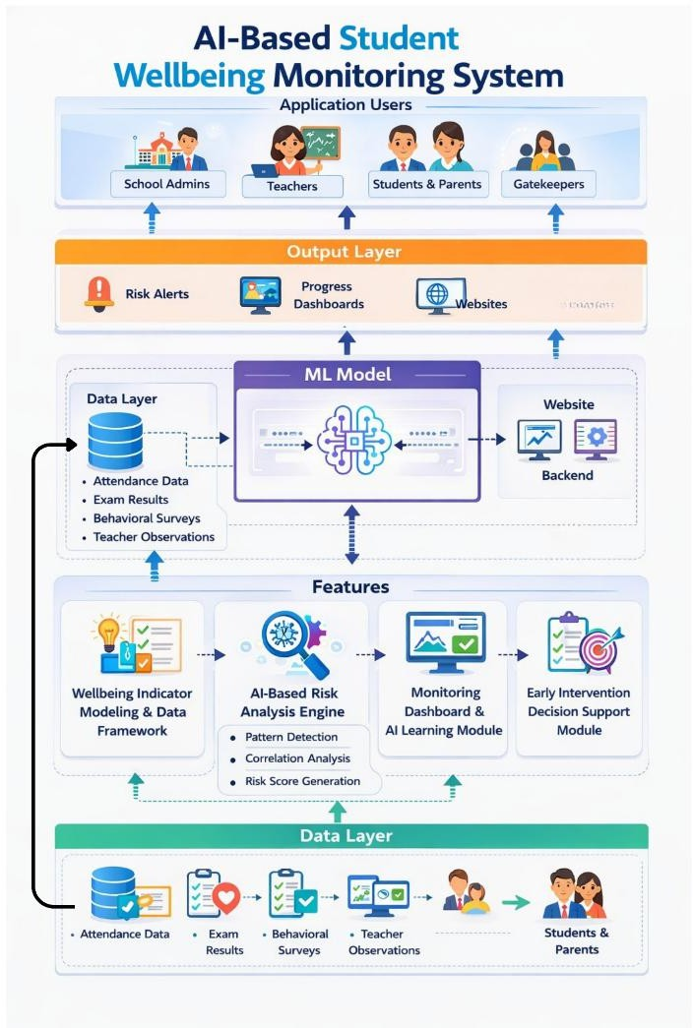
Figure 1-System diagram of components

Individual Component and Its Parts

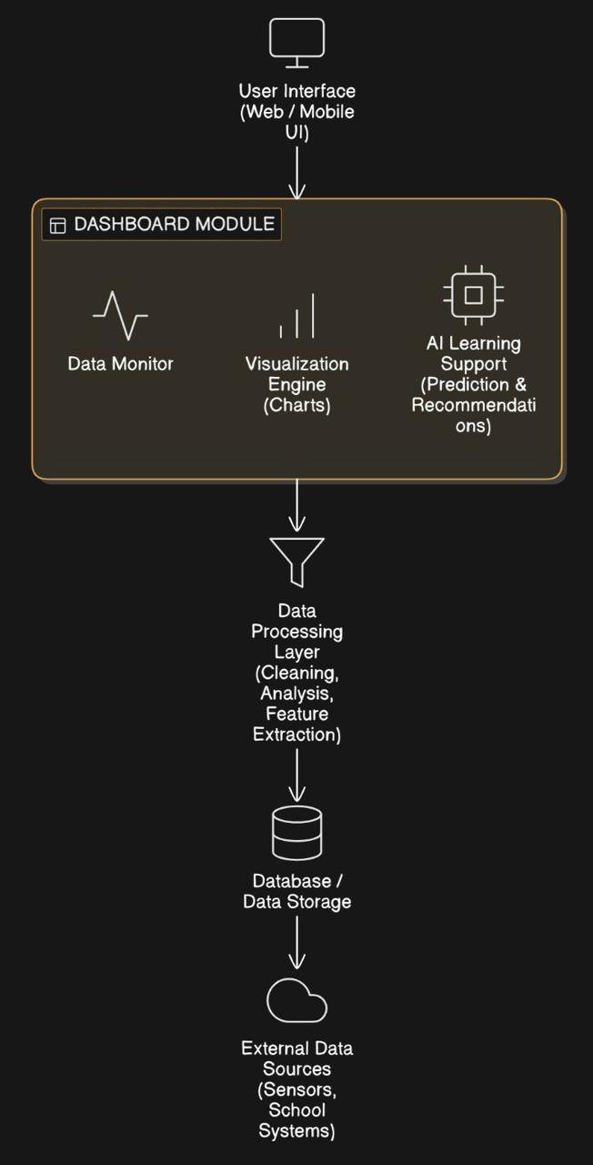
Figure 2-Individual Component

Component Interactions

The Monitoring, Visualization & AI Learning Support Dashboard is a key component of this system. It acts as the main interface where teachers, school administrators, and counselors can observe student wellbeing data and receive intelligent insights.
This component does not work alone it continuously interacts with other system components such as data collection modules, AI processing units, and user interfaces. These interactions ensure that real-time, meaningful, and actionable information is delivered to users.

Data Flow Explanation
Data flows from school-level inputs to the Lanka Government Cloud. The Analytical Core processes "Speed Layer" data (daily attendance) and "Batch Layer" data (term health records) to provide unified, real-time insights.

Scalability and Security Considerations

Scalability ensures the system can grow and handle more users, while security ensures that student data is safe and protected. Both are very important for building a reliable system for Sri Lankan schools.

USER REQUIREMENTS

Stakeholder Identification
- School Counselors: Require detailed psychosocial history and XAI narratives.
- Class Teachers: Need "Actionable Clarity" and simple check-in tools.
- Parents: Benefit from trilingual progress summaries and wellbeing nudges.
- Zonal Officers: Require district-level "Distress Heatmaps" for resource allocation.

Functional Requirements

- Sentiment Interrogation: Ability to query "Which students show social withdrawal signs?".
- Modular Wellbeing Tracking: Integration with the 2026 reform goals.
- Privacy-Enhanced Mode: Deleting session-level data after human clinical review.

Non-Functional Requirements
  - Accuracy
  - Scalability
  - Performance
  - Usability
  - Data Integrity

COMMERCIALIZATION PLAN

Target Market and Customer Persona
The primary target market operates on a B2B (Business-to-Business) and B2B2C (Business-to-Business-to-Consumer) model, focusing on educational institutions and e-learning platforms.

Universities, high schools, and private tuition networks looking to upgrade their existing Learning Management Systems (LMS).

1: The Institutional Administrator (The Buyer). Focused on retention rates, overall institutional performance, and resource allocation. They need high-level, aggregate data visualizations.

2: The Educator/Lecturer (The User). Time-poor and managing large classrooms. They need a dashboard that quickly highlights which specific students are falling behind and provides AI-generated suggestions for interventions.

3: The student (The End-User). Needs a clean, motivating, personal dashboard showing their progress, knowledge gaps, and AI-recommended study materials.

Value proposition
Current LMS platforms provide raw data, but they fail to provide actionable insights. Our dashboard bridges the gap between data collection and pedagogical action. For educators, it reduces the administrative burden of tracking student progress manually. For students, AI acts as a 24/7 personalized academic advisor, analyzing their interaction patterns to suggest custom learning paths and resources, ultimately improving academic outcomes and reducing dropout rates.

Revenue Model

The product will be commercialized using a Software-as-a-Service (SaaS) subscription model with tiered pricing:
- Basic Tier (Freemium/Individual): Free for individual teachers with basic visualization tools and limited student capacity. Acts as a funnel to institutional sales.
- Pro Tier (Per-Student/Monthly License): Designed for schools and mid-sized institutes. Includes full AI analytics, predictive modeling, and API integration with their existing LMS (e.g., Moodle, Canvas).
- Enterprise Tier: Custom pricing for large university networks requiring dedicated server hosting, custom AI model training based on their historical data, and white labeling (custom branding).

Cost Estimation
The initial development and operational costs are broken down into three main categories:
- Infrastructure & Cloud Costs: Cloud hosting (e.g., AWS, Azure) for real-time data processing, database storage for student logs, and compute power for running Machine Learning models.
- Development & Human Resources: Salaries for UI/UX designers, front-end developers (for the dashboard), and data scientists (for the AI learning support engine).
- Operational & Marketing: API licensing fees, data security compliance audits (essential for handling student data), and marketing/sales expenses to acquire institutional clients.

Competitive Advantage

Our primary competitive advantage is the integration of prescriptive analytics. While competitors (like standard Moodle dashboards or basic Tableau integrations) offer descriptive analytics (showing what happened), our AI engine offers prescriptive analytics (advising on what to do next). Furthermore, our lightweight visualization architecture will ensure high performance even on low-bandwidth connections, making it highly accessible in developing regions.

Intellectual Property Issues

Commercializing this software involves several critical IP and legal considerations:
- Data Privacy & Compliance: The system must strictly adhere to data protection regulations regarding student data (e.g., GDPR, FERPA). We do not own the student data; we process it. Data must be anonymized before being used to train broader AI models.
- Proprietary Algorithms: The specific Machine Learning models and the logic connecting student behavior to AI interventions will be protected as a trade secret and potentially filed for a utility patent.
- Copyright: The source code, UI/UX designs, and the specific arrangement of the visual dashboard will be protected under standard software copyright laws.

BUDGET AND JUSTIFICATION

Description | Cost (LKR)
Hardware (Development Laptop / System) | 150,000
Cloud Services (Hosting C Storage) | 30,000
Software and Tools (Development C ML  Libraries) | 20,000
Internet and Data Access | 20,000
Human Effort (Development C Testing) | 200,000
Total | 420,000.00

The above budget represents the necessary resources that will be needed for the development and
deployment of the AI Based Risk Analysis Engine. The hardware costs will include necessary resources that will be used for computation during the development and testing phase of the model. Cloud services will be necessary for hosting the application and for data processing. The software costs will be low as it will be using free tools and technologies, and internet costs will be necessary for development. The
necessary costs will be for human resources for development and for implementing the model, as they will be crucial for the accuracy of the model. The above budget is cost-effective, as it will have a high impact for the early detection of students at risk.

WORK BREAKDOWN STRUCTURE

Work Breakdown Structure

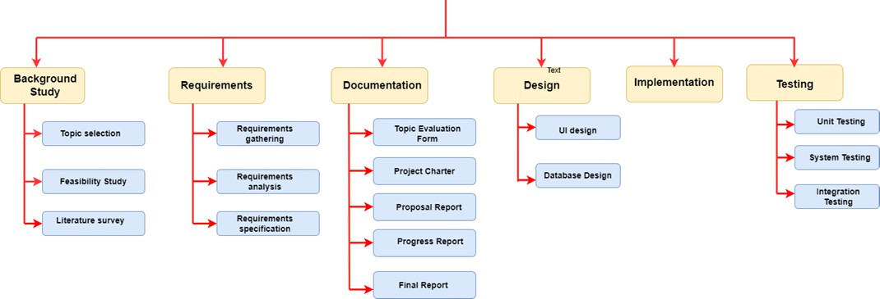

Figure 3-Work Breakdown Structure

GANTT CHART

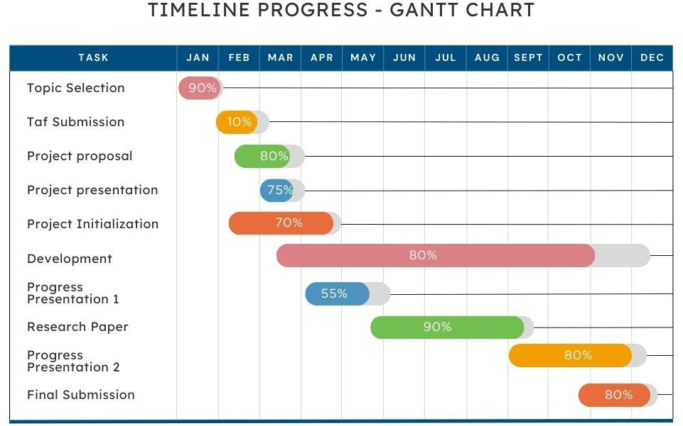

Figure 4-GANTT CHART

REFERENCES LIST
- Baker, R. S., & Inventado, P. S. (2014). Educational data mining and learning analytics. Learning analytics: From research to practice, 61-75.
- Bodily, R., & Verbert, K. (2017). Review of research on student-facing learning analytics dashboards and educational recommender systems. IEEE Transactions on Learning Technologies, 10(4), 405-418.
- Gasevic, D., Dawson, S., & Siemens, G. (2015). Let’s not forget: Learning analytics are about learning. TechTrends, 59(1), 64-71.
- Holmes, W., Bialik, M., & Fadel, C. (2023). Artificial intelligence in education: Promises and implications for teaching and learning. Center for Curriculum Redesign.
- Schwendimann, B. A., Rodriguez-Triana, M. J., Vogüez, S., Prieto, L. P., Boroujeni, M. S., & Dillenbourg, P. (2017). Perceiving learning at a glance: A systematic literature review of learning dashboard research. IEEE Transactions on Learning Technologies, 10(1), 30-41.

